|  |  |
| --- | --- |
| **To: Professor Darish** | **Date: November 4, 2014** |
| **From: Trever Wagenhals** | **Course & Section Number:** |
| **Subject: Superposition in electrical circuits** | **Partner(s):**  **TA: Kyle** |

**SUMMARY:**

**EXPERIMENTAL APPROACH**

**Equipment and Materials**

* Resistors
* Breadboard
* Power Supply
* Multimeter
* Test Leads

**Summary:**

This lab involved calculating the currents and voltages of a circuit with multiple independent supplies. In order to calculate this, the superposition method must be used to get the correct values. Superposition involves turning one independent source off at a time and getting the measurements for all values while one is turned off. Next, the opposite supply will be turned off while the other is left on. When added together, the actual voltage and current readings can be retrieved.

**Procedure:**

First, create the circuits shown in Figure 6-1. Start out by creating the total circuit with both supplies turned on. Get all the measurements theoretically and measured and recorded in Table 5-1. Next, turn off the 10V supply as shown in figure (b) and perform the same steps. Lastly, turn off the 15V source and leave 10V on and take the measurements of all currents and voltages in the system.

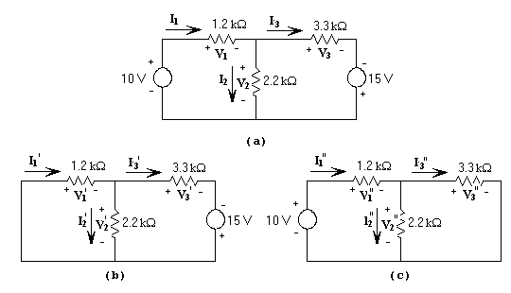

**Discussion of Results:**

When comparing the calculated results to the measured results, the error is almost non-existent. This method is extremely accurate. If a different method, such as mesh analysis, was attempted solely on the initial circuit, then the voltage and currents might not all end up being identical. If the data was looked at, it is easy to see that V1 and its identical V3 always add up to the initial total voltage sources. Also, Vx’ and Vx’’ always add up to the initial voltage source for the circuit with both supplies on. Similar trends can be seen with the currents, with the two currents always adding up to the initial dual supply circuit. The summary of each I2 and its identical I3 equal I1 as well, just like with the voltage.

Table 5-1.

|  |  |  |  |
| --- | --- | --- | --- |
|  | | Calculation | Measurement |
| Voltage | V1  V1′  V1″ | 7.619V  2.857V  4.76V | 7.630V  2.867V  4.764V |
| V2  V2′  V2″ | 2.37V  -2.856V  5.238V | 2.370V  -2.865V  5.235V |
| V3  V3′  V3″ | 17.38V  12.143V  5.237V | 17.377V  12.138V  5.239V |
| Current | I1  I1′  I1″ | 6.349mA  2.381mA  3.968mA | 6.417mA  2.409mA  4.003mA |
| I2  I2′  I2″ | 1.082mA  -1.298mA  2.381mA | 1.082mA  -1.316mA  2.381mA |
| I3  I3′  I3″ | 5.267mA  3.6796mA  1.587mA | 5.374mA  3.754mA  1.618mA |

**Questions:**

* **Explain superposition theorem in terms of the voltages across the resistors and currents I1, I2, I3.**

Superposition theory, as stated above, allows for a circuit with multiple supplies to be calculated simply by turning one off, making calculations, then turning the opposite one off and adding up the results. The measurement of a superposition circuit are always identical to the summation of the two individual single source circuits.

**In your own words, list the steps required to apply the superposition theorem.**

In order to apply superposition, a circuit with two independent sources must be present. Next, the ability to shut off each independent source must be doable. To calculate the dual source circuit, simply turn one source off at a time and calculate the current and voltage values. After, turn on both supplies and take the measurements of the currents and voltages to compare to the two single source circuits. The values of the two single source circuits in reference to each identical voltage and current should always add up to the voltage of the dual circuit. If the values do not add up, the circuit may be incomplete somehow or a mathematical miscalculation was made.